**My Tumblr Selected Posts**

A web application to retrieve Tumblr posts through the Tumblr API with posts tagged with the keyword “#happy”. The posts are displayed in a table with other information such as the post ID, blog name, date and note count. The project has been implemented with PHP as the server side language and ReactJS as the client side language along with HTML and CSS. The table contains 10 posts per page with a total of 120 posts and paging is enabled for ease of viewing the results by the user. The columns are sortable as well as filterable so that users can search for the desired post from a date, note count or blog. The link in the Text column takes the user directly to the permalink of the post.

**Getting Started**

These instructions will get you a copy of the project up and running on your local machine for development and testing purposes.

**Prerequisites**

Below is the list of softwares to be installed.

1. PHP7
2. Composer
3. React
4. ReactTable library
5. Node >= 6

**Installing**

Please install the following for complete setup of the dev environment.

1. Install PHP7 on the machine

Ref: <https://www.sitepoint.com/how-to-install-php-on-windows/>

1. Install Composer
2. Install React:

I installed the IDE Visual Studio for React

Ref: <https://github.com/facebook/create-react-app>

1. Install the ReactTable library

npm install react-table

Ref: <https://github.com/react-tools/react-table/blob/master/README.md>

**Running the app**

Start by running the “index.php” file from the command prompt by going to the folder containing the file.

cd C:\PHP7\php-docs-hello-world-master

Run the command “php –S localhost:8080” to start the local server.

In the browser go to <http://localhost:8080>

The browser displays a “success” message upon successfully creating the json file or “failed” message otherwise. In case failed, try running again.

The JSON file “tagged_posts_file.json” containing the posts is created in a directory accessible by React. Here folder called “my-app”.

In another command prompt window cd to the “my-app” folder

cd C:\PHP7\php-docs-hello-world-master\my-app

Then type:

npm start

From the browser navigate to <http://localhost:3000/> to see the app in action.

**Screenshot:**

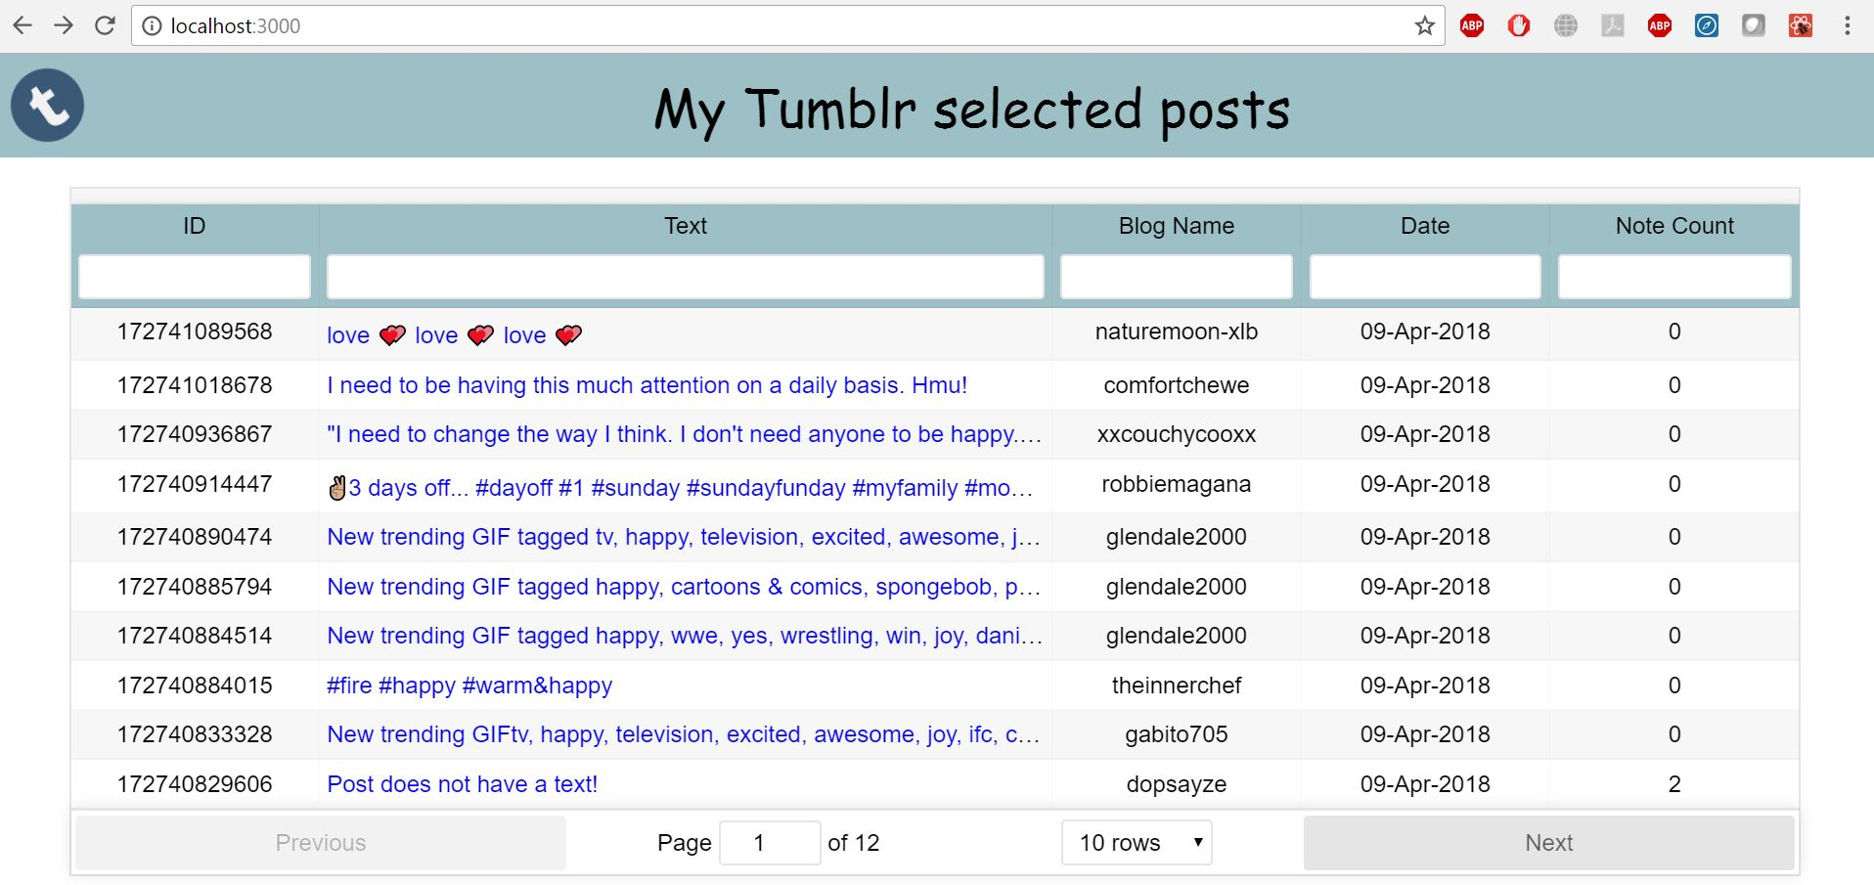

**Built With**

* Sublime Text
* Visual Studio Code

**Authors**

* **DEBIKA DUTT**

**Acknowledgments**

* StackOverflow : <https://stackoverflow.com/questions/47311845/print-more-than-20-posts-from-tumblr-api>
* Tumblr API doc : <https://www.tumblr.com/docs/en/api/v2>
* Git : <https://github.com/tumblr/tumblr.php>